
Hyderabad

Funds Transfer

Software Requirements Specifications
Version 1.0



January,2013

Warning
This is a hard copy of a document maintained on electronic media. It may not be the latest version. Kindly ascertain the latest version from the Document Master List available with the Project Leader.

DOCUMENT RELEASE NOTICE

Document Details:

Name | Version No. | Description
Software Requirements Specifications | 1 | SRS document for Funds Transfer of UBS

Revision Details

Action taken  (Add/Del/Change) | Preceding Page No. | New Page No. | Revision Description

This document and any revised pages are subject to document control. Please keep them up-to-date using the release notices from the distributor of the document.

Approved by: Date:

Authorised by: Date:

PREFACE

Purpose of this Document

This document describes the System Requirements Specifications of the United Banking Service (a multi-banking system). This document lays down the software requirements for the application that have been captured through a detailed study of the business work flow and functions.

Intended Audience

- Developer, Team Lead, Project Manager
- Tester
- Client

This document is intended for use by the developers,testers and clients of the system, and for those who may be required to maintain it. The document will enable them to understand all aspects of the system in detail. It will enable the United Banking Service to know that Fund transfer system has captured all the requirements. The document will also be used by Unite Banking Service for carrying out the acceptance testing.

Related Documents / References

The following documents have been referred to for the preparation of this SRS document:

- ‘Multi-banking_case_study’ : Technical Proposal for the study.

Acronyms and Abbreviations

Abbreviation/Acronym | Description
UBS | United Banking Service
SP | Service Provider
GUI | Graphical User Interface

*Organization of this Document

This document consists of 6 sections and appendices.

Section 1: Introduction
Section 2: Requirements
Section 3: User Interface Specifications
Section 4: Use Case Analysis
Section 5: Other Requirements
Section 6: Appendix A
Section 7: Glossary of terms.

TABLE OF CONTENTS

1. Introduction 1
2. Functional Requirements 4
3. User Interface Specifications 6
3.1.1 Screen Description 22
3.2 GUI Report Layouts 22
3.2.1 Report Layout 22
3.2.2 Report Description 22
4. USE CASE SPECIFICATIONS : 23
4. 5. Other Requirements 33
4.1 Generic Requirements 33
4.2 User Access Control and Security 33
4.3 Archiving and Housekeeping 33
4.4 Performance Requirements 33
5. Appendix A: Analysis Object Model 34
6. Glossary of Terms 35

Total Number of pages: 43
<To update the number, right-click on it and select Update Field. It will insert the actual number of pages in the document>

Introduction
1.1 Background
This document outlines the software requirement specification for the United Banking Services .It is the outcome of the Analysis Phase during which discussions were held with the users. The objective of this Analysis Phase was to:

- Define the scope for the Multibanking System.
- Serve as the baseline for the design of the MultiBanking System.

Any changes to requirements after acceptance of this document will be through appropriate Change Management procedure, as detailed in the contract.
.

Client Details:
United Banking Services is a new entrant in the Banking Sector.

Project Details:

Multibanking allows customers of any bank to register to MultiBanking Ltd and enables customers to make all their financial transactions involving various banks on a secure website. Customer needs to register in the system and can have access to facility of fund transfer .Registered customer has the liberty of adding/deleting/updating the details of the account in which he/she is willing to transfer the fund.

Module Requirements:
There are 3 modules in this Project. They are
- Account Profile
- Fund Transfer
- Request Management

1.2 Scope
Referring to the technical proposal document the following functionality and scope have been identified.

In Scope,

1.Log-in Page

    - Separate Authentication for the customer and the admin.
    - Displays error message in case of invalid user id or password.

Account Profile Module:

2. Customer Home Page:

1. Customer is the only user.
2. Contains the links for
- Add Account
- Update Account
- View status/account
- Delete Account
- Transaction history

3. In accordance with the links clicked by the customer respective pages are displayed.
- A button fund transfer is for the purpose of fund transfer.

3.Add Account Details Page:

- Customer is the only user.
- Customer can add details of the person (payee) such as account details who is to be added for the purpose of fund transfer.
- On submission of the required fields ,details are forwarded to the admin for verification.

- Update Account Details Page:

- Customer is the only user.
- All the accounts(payee) added by the customer are displayed on this page.
- Customer can click the edit link to update details of account .

- Delete Account Details Page:

- Customer is the only user.
2. All the accounts(payee) added by the customer are displayed on this page.
- Customer can click on the delete link to delete the details of account.

- View Account/Status:

1. Customer is the only user.
- Customer can view all the accounts(payee) details.
- Also corresponding to every account , status is displayed statinf its rejection/approval by the admin.

Fund Transfer Module:

- Fund Transfer Page:

1. Customer is the only user.
- All the accounts(payee) added by the customer are displayed on this page in the form of options of radio buttons.
- Customer can select a particular account(payee) from the options for fund transfer.
- Two textboxes are present on this page for the user to enter the amount to be transferred and add
remarks.
- A button “Transfer” is present and if the customer clicks this button fund transfer process is
initiated ,user is directed to the transaction password page.

8. Transaction Password Page:

- Customer is the only user.
- Customer is supposed to enter the transaction password .
- If customer clicks on the submit button then an alert box is displayed stating transaction was
successful.

9. Transaction History Page:

- On this page all the transactions made by the customer from all his accounts will be displayed.

Request Management Module:

- Admin home Page:

- Admin is the only user.
- It will contain link for Manage Requests.
- If the admin clicks on this page ,he/she shall be directed to the page of manage request.

- Manage Request Page:

- It shall consist a list of all pending request regarding addition of accounts(payee) for fund
transfer.
- Status column of the list shall be editable by the admin .
- Status will have a dropdown list with two items “Approve” and “Reject”.
- Admin after verifying the details of the account(payee) shall set the status accordingly.

1.3 Business Justification for Investment
The reasons for which the software has to be implemented are as follows:

- Complete automation of the process.
- Make the work easy for user(Customer,Bank)
- Reduce human errors.
- Secured data storage
- To cater the needs of the increase number of customers.
- On a long term perspective handle customer details in an efficient manner.
- By providing easy interface ,attract more customers and expand business.

1.4 Product Perspective
The current practice in banking sector is a linear model where the customer has to visit bank for fund transfer .A slip is to be filled by the customer which consists of the account details involved in fund transfer. The slip is to be submitted at the respective counter and then the fund transfer takes place. This process is very time consuming. Our new automation system simplifies fund transfer process enabling several customers to access the multibanking system and get fund transfer without visiting the bank.

1.5 Key Assumptions, Dependencies, Constraints and Overriding Priorities
The successful execution of the assignment will depend on the following factors:

Assumptions
- There is only one Admin and Admin Id cannot be updated.
- Transaction password for each customer already exists.
- Details entered by customer is genuine
- The program will be running on a multi-Bank model.
- There is a in-built system for the Admin to communicate with any bank's systems and databases.
- The customer can add another customer of same or different bank for making the fund transfer

Dependencies

Constraints
- Admin approves/rejects request within 24hours of request submission
- The customer transfer money to another bank or same bank who are already in his account.
- For adding, the customer need to provide the details like account number, IFSC code, branch and bank of the customer's account which needs to be added along with the name and email id.
- Customer has maximum transferring limits of 50000rupees.

1.6 User Classes and Characteristics
This application has two primary users:
- Customer
- Admin

So there are two main user classes
Customer Class:
- Perform Customer related operations
- Can add another account for transferring funds
- Can view all the added accounts in his account
- Can update the details of added accounts
- Can delete the details of added accounts
- Can transfer the funds to same/different bank
- Can close the funds transfer
- Can view all the previously transferred funds

Admin Class:
- Can view all pending request for adding accounts for fund transfer.
- Can verify details of the pending requests
- Can approves/rejects the request after verification

1.7 Hardware and Software Platform
Software Platform:
- OS : Windows XP Professional, Version 2002, Service Pack 3
- Software: putty, winscp
- Visual Studio 2010
- Database server: MS SQL Server 2008

Hardware Platform:
- Server : Linux 2.6.18-194.el5 x86_64
- Processor: Core2Duo, 3.00 GHz frequency
- RAM: 2 GB

1.8 Site Adaptation
To use UBS application, user must have a good web browser installed on the system , and MS SQL server installed at their site. For site adaptation following documents will be provided:
- SQL document, which contains all the queries to create tables, sequences, and triggers.
- Executable file of source code.

1.9 Application Security
- Login id and login password is provided to all the customers and the admin, and depending on the role, they have different page restrictions. A customer can add, view, update, delete the added customer profile and transfer the funds whereas an agent is responsible for request management.
- The password is protected such that not even the characters are displayed
- There is provision to ask secret question, if user forgets his/her password.
- Different validations are applied at user interface level and database level.

Functional Requirements
This section describes various functional and non-functional requirements of the fund transfer system

2.1 Functional Requirements

There are two main users of application:
- Customer
- Administrator

2.1.1 Customer Functionality:

- Can log-in to the multi-banking system
- Add details of another registered customer for fund transfer
- View his/her details.
- Update his/her details.
- Delete his/her details
- Transfer funds
- View Transferred Funds History

2.1.2 Administrator Functionality:

- Views all pending request for adding accounts for fund transfer.
- Verifies details of the pending requests
- Approves/Rejects the request after verification

2.2 Non-Functional Requirements

- Log-in process should be robust.
- Good user/Role management options.
- To cover validation scenarios, error messages should be displayed.

2.3 Validation Requirements

2.3.1 Addition of new Account
While entering the customer details, the following validations are taken into considerations.
- Check if customer details are entered correctly
- Validate name, account number, email id, password and other fields .

2.3.2 View Account/Status
Valid customer id should be entered into the search button.

2.3.3 Update details
During updation of account details , the following validations should be done.
- Check whether the account exists in the database.
- Validate each field as per its scope.

2.3.4 Delete details
Select the account that have to be removed.

2.3.5 Transfering funds
While transfering funds following validations have to be done
- Check whether the account where the funds have to be transferred is a added by the customer.
- Check whether the amount to be transferred is less than Rs.50000.
- Validate the transaction password entered by the customer.

2.3.6 View Transferred Funds history
Validate the date entered by the customer.

2.3.7 Request management
Admin must validate the customer details before servicing their requests.

User Interface Specifications
3.1 Navigation Chart
This is the basic navigation of all the modules involved in the project and gives the information of how to navigate to each page.

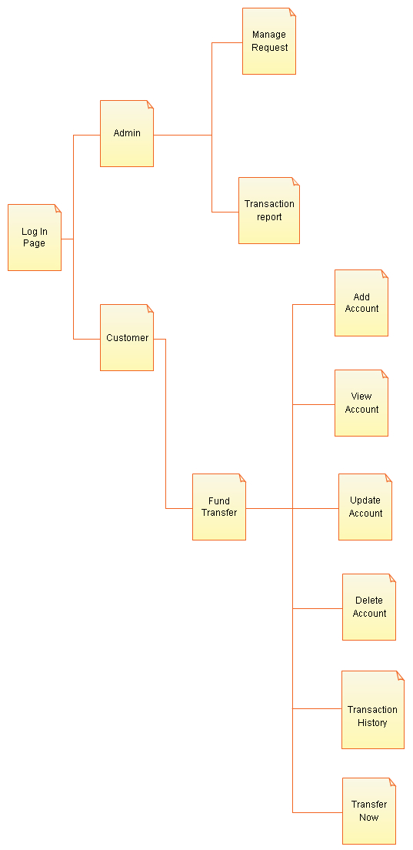

3.2 Domain Diagram

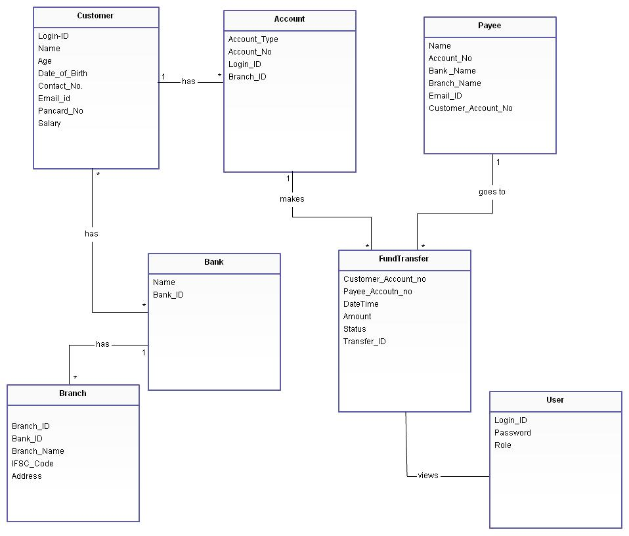

3.3 Activity Charts

3.3.1 Log-in

Description:The user/admin should log-in by entering his details. If the details are correct the system will redirect to home page of funds transfer.
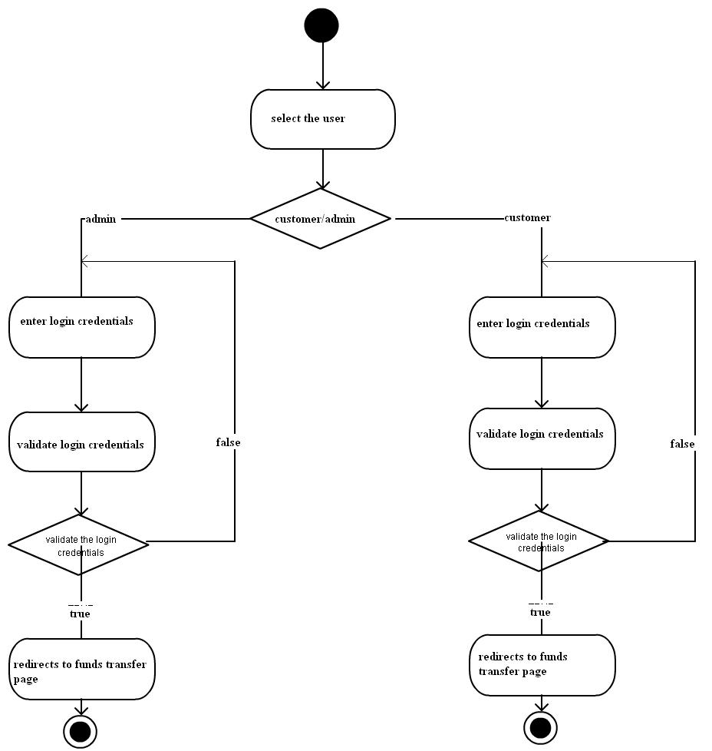

3.3.2 Add new account

Description: After log-in user is redirected to home page of funds transfer. He can add an account by clicking on the 'add new account' providing necessary details. After adding the details are validated. If found correct, the details are saved, if not the status is displayed as rejected.
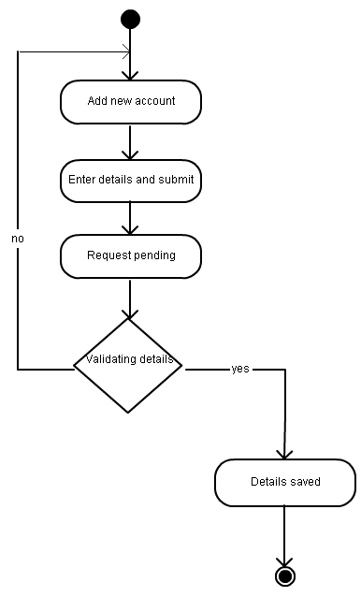

3.3.3 : View Details

Description:The user can delete customer details by selecting the details of customer.

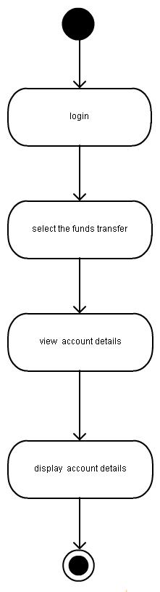

3.3.4 Update account

Description: The user can also modify the account details. While modifying user should consider all the validations specified, If not error message will be displayed.

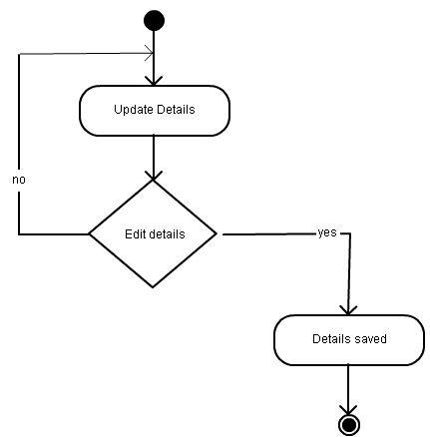

3.3.5 Delete an account

Description: The user can delete customer details by selecting the details of customer.

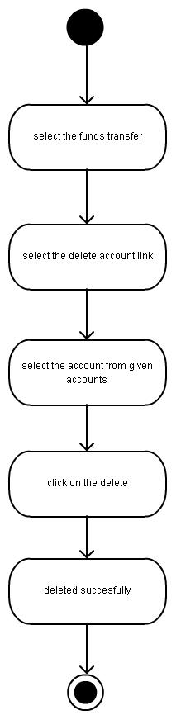

3.3.5 Fund Transfer

Description: The user can transfer amount by clicking on self or third party. User selects the account details, amount to be transferred and clicks on transfer button. He will be asked for transaction password. The transaction credentials are validated,if found correct transaction will be successful , if not the same page is loaded back.

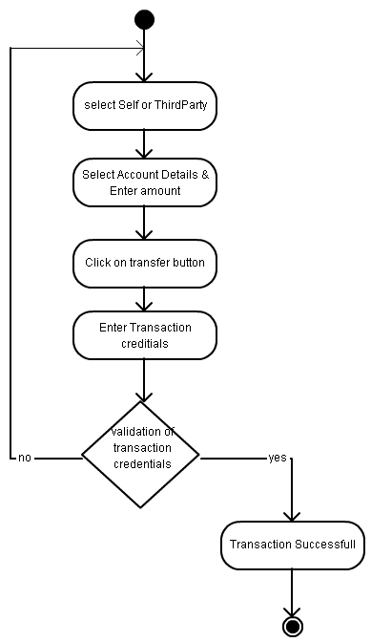

3.3.6 Funds Transaction history

Description: User clicks on the funds transfer link. Next he clicks on the funds transfer history and selects the from-date and to-date. He views his transaction details.

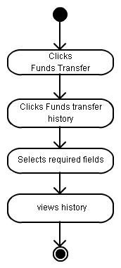

3.3.7 Request Management

Description: Admin clicks on funds transfer. He is redirected to funds transfer page. Next clicks on management requests, views all pending requests and validates all requests.

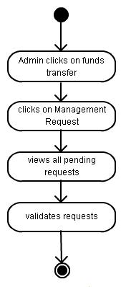

3.4 GUI Screen layouts
Login:
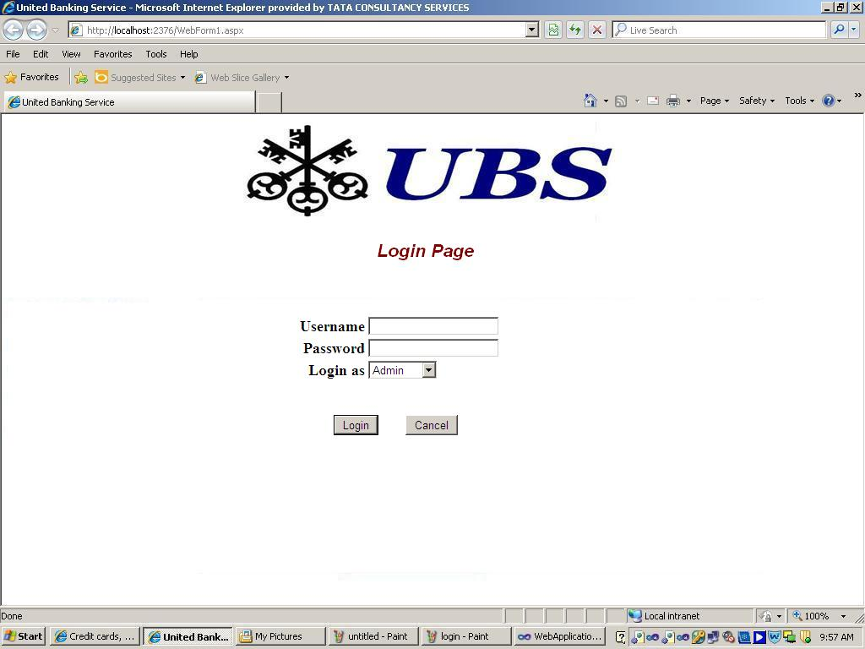
Customer Home:

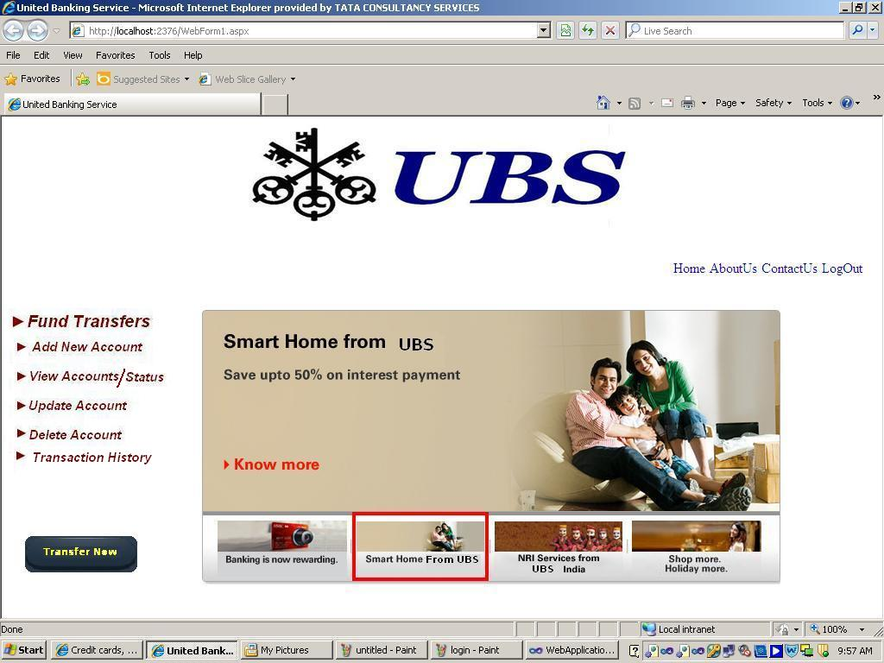
Add Account Details:

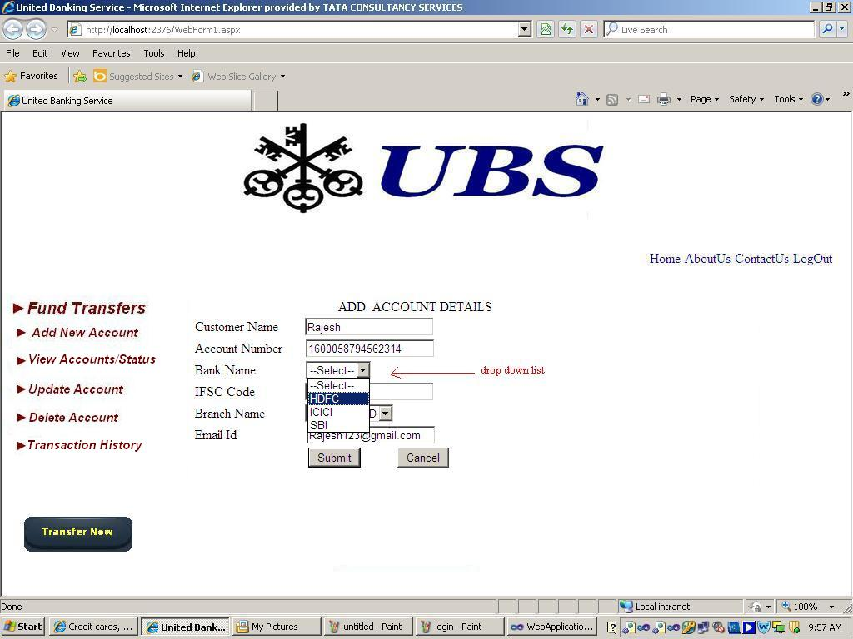
Add validations:

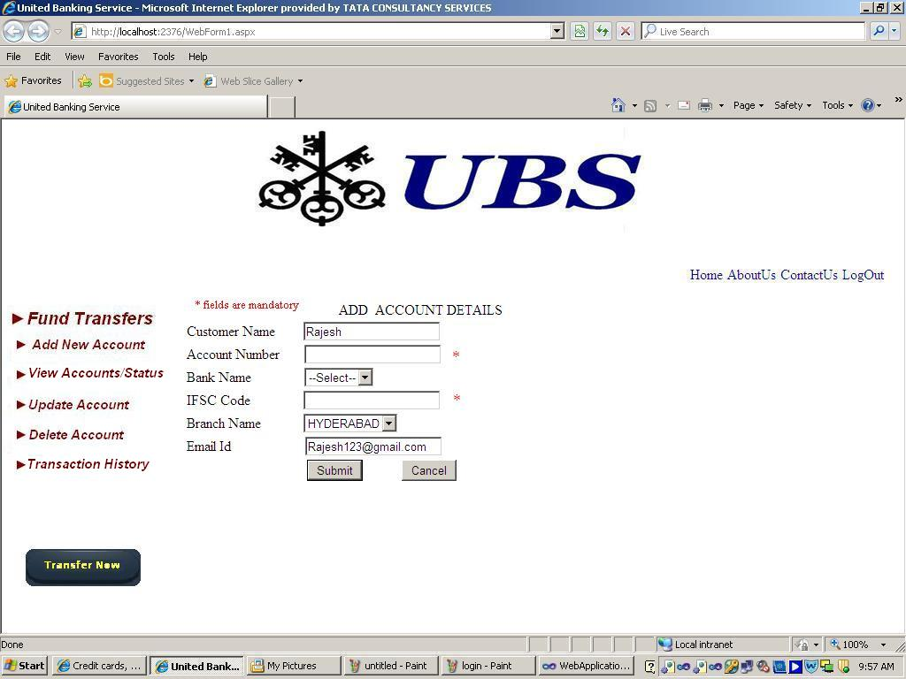
Update details:
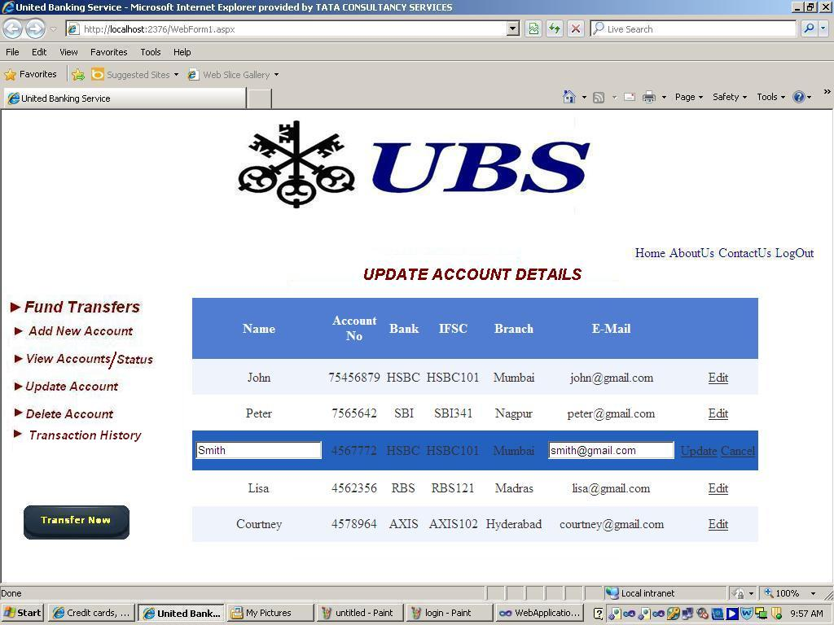
Delete details:

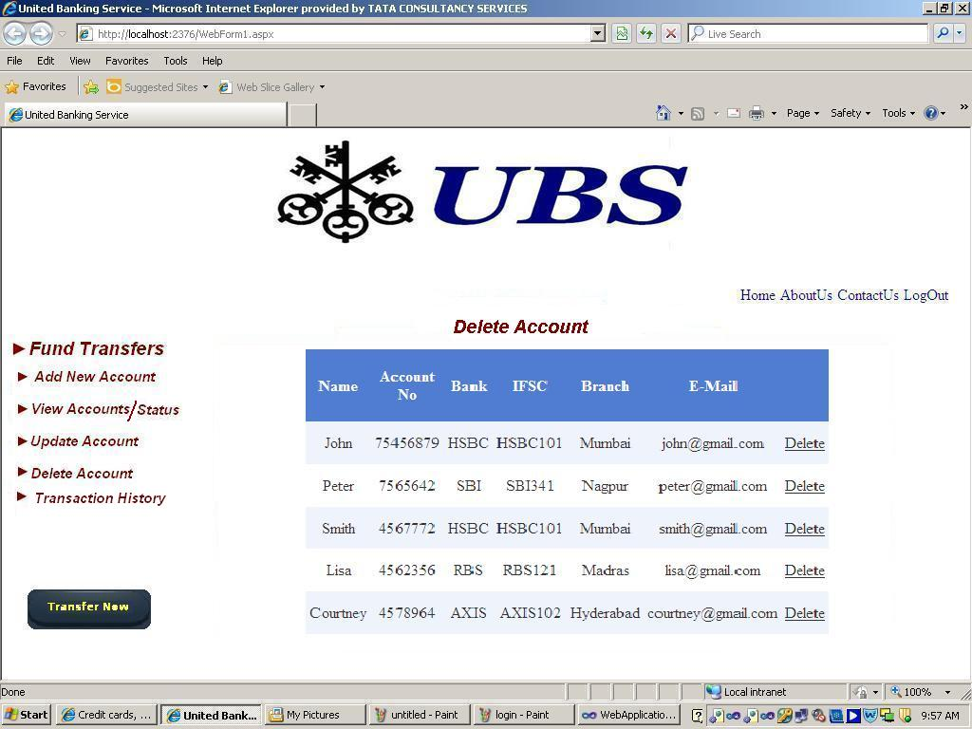
View accounts:

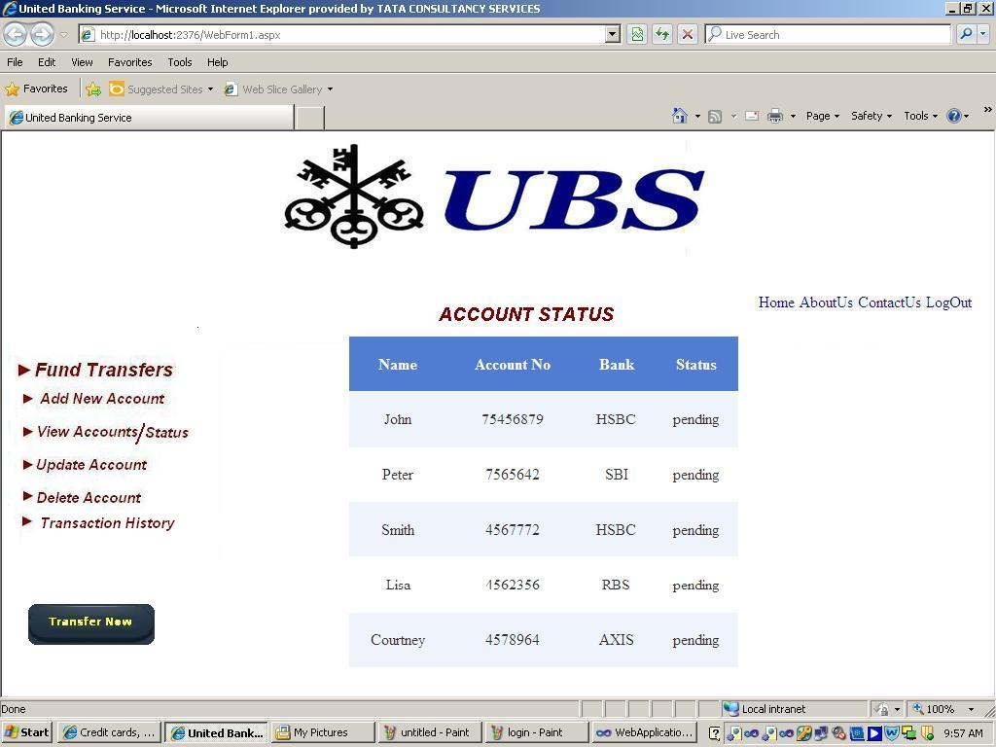
Fund Transfer:

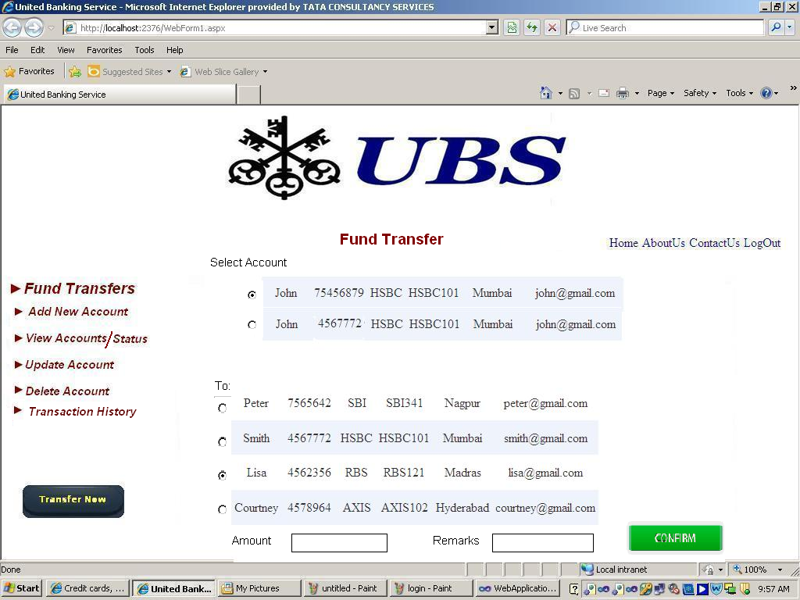
Transaction Password:

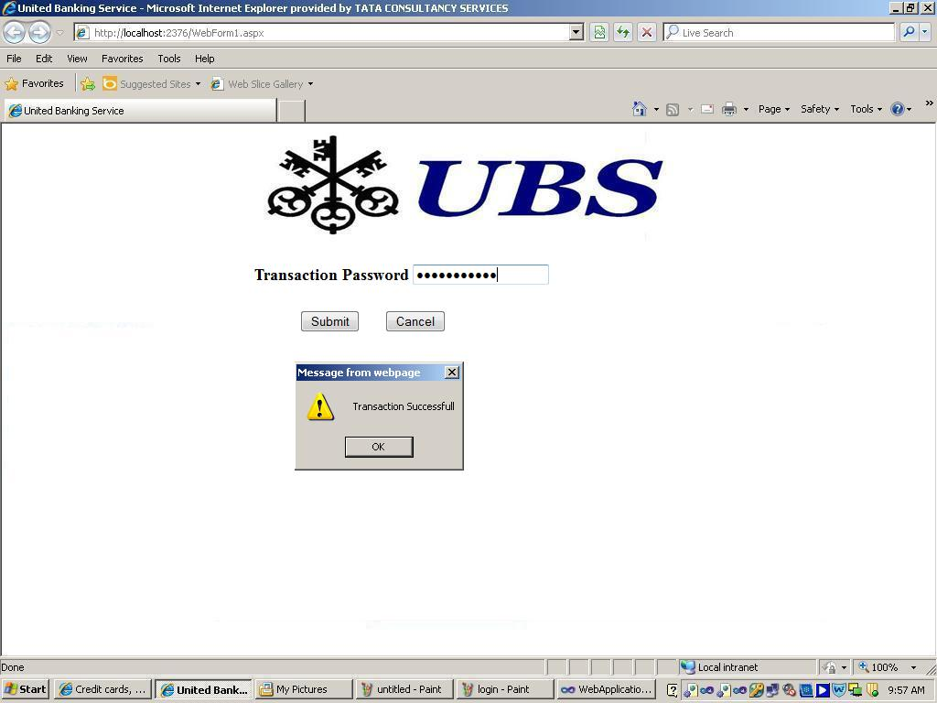

Customer Transaction History:

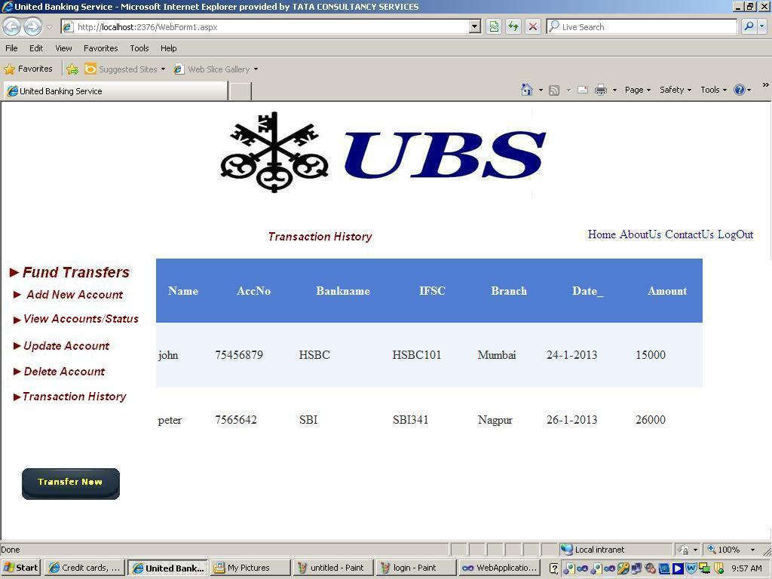

Admin home page:

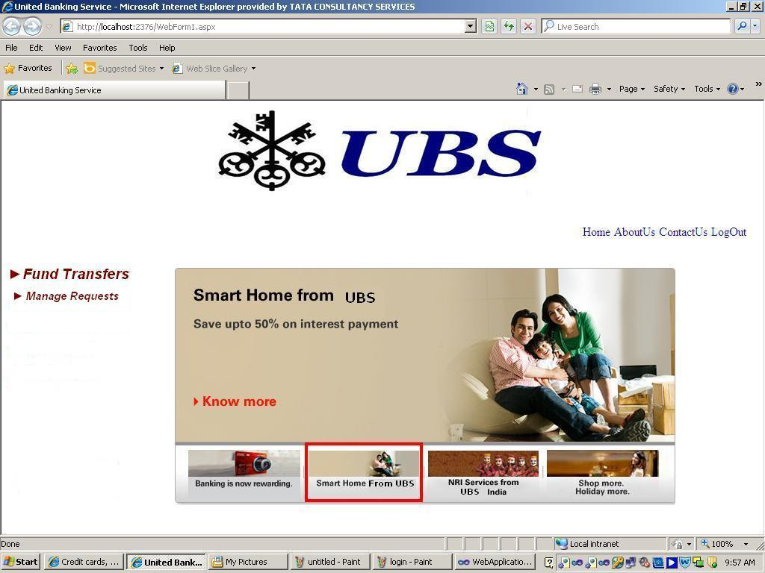
Admin management request:

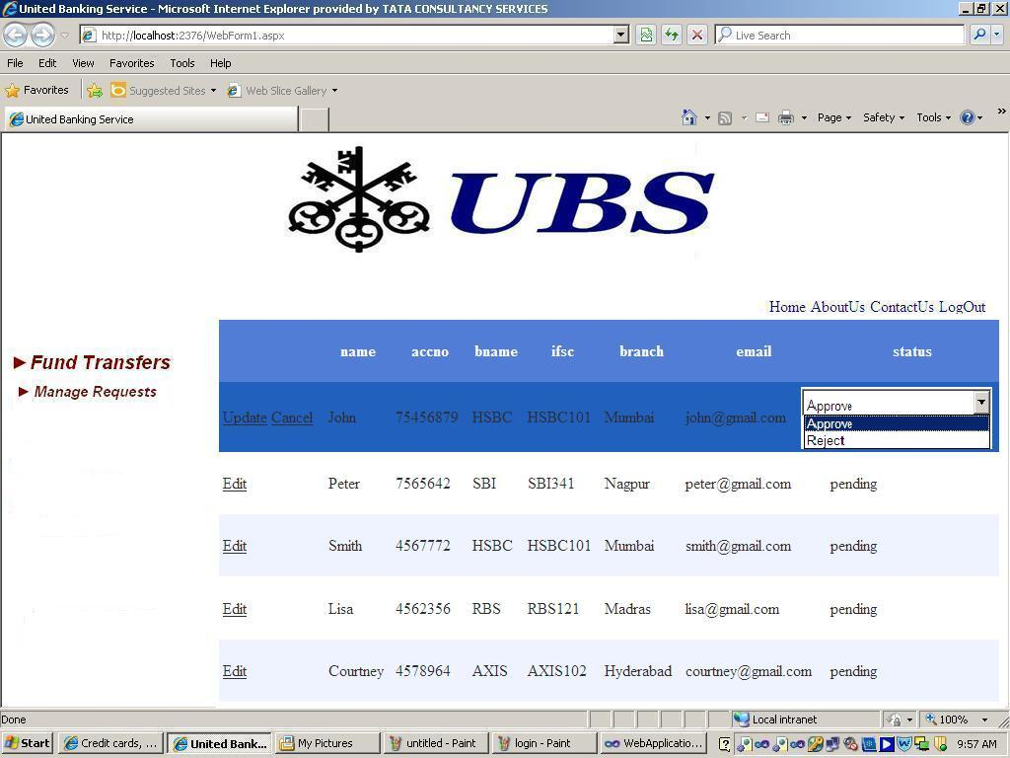

Screen Description
<Each screen layout should have an accompanying narrative. a.
<Details of the screen may be given in the following format:>

Attribute Name | Description | Remarks

GUI Report Layouts
<Give a brief description of the sub-section>

Report Layout
<The Report layout should be included in this section.>

Report Description
<Each report should be briefly described. A sample format is given below:>

Title: | Title of the report
Purpose: | Business purpose for the report
Intended Users: | Intended distribution
Frequency: | Frequency of generation
Report Sequence: | Description of the required sequence
Business Logic: | Description of any specific processing logic

4. USE CASE SPECIFICATIONS :
Use Case Model for United Banking Service Fund Transfer

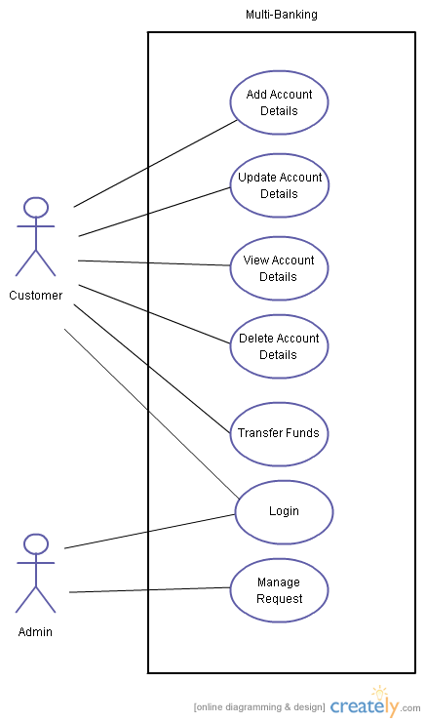

Use Case name : Log in
Level: User goal
Scope: United Banking Services(UBS) Fund Transfer
Primary Actor: Admin, UBS Customer.
Stakeholders and interests:
UBS Customer: Wants to log-in to transfer funds from his account to other account by adding their account details
Admin: Wants to log-in to verify the details added by the UBS customer for funds transfer.
Preconditions: Should be a registered user.
Success Guarantee: Upon successful log-in of the UBS customer, he will be redirected to the home page.
Main Success scenario:
1.UBS customer/Admin provides user name and password and clicks on log-in button.
2.UBS customer will be redirected to funds transfer home page.
3.If Admin logs in, he will be redirected to verifying page.
Extensions:
1a. Invalid user name or password of UBS customer/Admin.
System generates error message.
System displays Login page
Assumptions: None

Module 1:Account Profile

Use Case UC1: Add New Account
Level:Use goal
Scope: United Banking Services Fund Transfer
Primary Actor: UBS Customer
Stake Holders and interests:
United Banking Services: Provides users with different banking facilities of various banks.
UBS Customer: Wants to add people having bank account to UBS for the purpose of fund transfer.
Preconditions:
Success Guarantee: Added account status in the View Account/Status will be 'Added'
Main Success Scenario:
- UBS customer logs into the UBS by providing credentials.
- Clicks on the link of fund transfer.
- Selects whether new account is of same bank or different bank.
- Enters the details of the person such as name, account number, bank name, branch name and email address.
- Clicks on Submit Button
- Admin validates and verifies the details provided by the customer within 24hours.
- If approved by the admin, customer details are saved in the UBS customer’s account.
- The status of the added new account in the View Account/Status page will be 'Added'.
Extensions:
1a. Invalid credentials are given by the UBS customer.
System displays error message.
Login page is displayed again.
5a. Customers cancels the process.
System redirects to Funds Transfer page.
Assumptions:
    - Customer enters genuine details

Use Case UC2: View Account/Status
Level: User goal
Scope: United Banking Services Fund Transfer
Primary Actor: UBS Customer
Stakeholders and interests:
UBS Customer: Wants to view the details/status of the accounts of the same bank or other bank added in his account for making fund transfer.
UBS Fund Transfer: Wants to give a view to the UBS customer, the details of the customer accounts of the same bank or the other banks added to the UBS customer account to make fund transfer.
Preconditions:
- The customer is already registered with the UBS.
- He already had added some accounts to his account.
Success Guarantee: Customer details added by the UBS customer to his account are displayed.
Main Success Scenario:
- UBS customer logs into the UBS by providing credentials.
2. Clicks on the link of fund transfer.
3. UBS Customer selects to view the details of all the accounts he added into his account.
- UBS Customer enters the details into the system.
- System validates the UBS customer details.
- System generates a table with the details of all the customer accounts added in his account, for the UBS customer.
Extensions:
1a. Invalid Customer Details.
System displays an error message.
System displays menu.
2a. UBS Customer requests to view details.
System displays the details of the accounts added to the UBS customers account.
System displays menu.
Assumptions: None

Use case uc3: Update Account Details
Level: user goal

Scope: United Banking Services Fund Transfer

Primary Actor:UBS Customer

Stakeholders and Interests:

UBS Customer: wants to update customer account details

Admin: wants the system to accurately update the details done by the UBS customer

Bank: update the necessary details

Preconditions: UBS Customer should be already registered.
Editing Account details already exists.

Success Guarantee: the UBS customer is given a notification.

Main success scenario:
- Customer logs on to the system.
2. Clicks on the link of fund transfer.
- Customer selects Update Account Details link
- customer clicks on edit for editing particular account details
- customers modifies name and email address of editing account.
- Customer clicks on update.
- System saves the changes.
- Customer is notified that successful changes are saved.

Extensions:
1a. Invalid login credentials.
System displays an error message(Invalid user).
System redirects to Login Page.
6a. Customer enters invalid details.
System Displays error message.
System redirects to Update Account Details page.
6b. customer cancels the updation.
System do not save any changes.
System redirects to Update Account Details page.
7a. System fails to update the changes
System displays an error message(an error occurred while processing)
System redirects to Update Account Details page.

Assumptions: Admin has verified the added account details. So only Name and Email address is allowed to modified.

Use Case UC4: Delete Account Details
Level: User goal
Scope: United Banking Services Fund Transfer
Primary Actor: Customer
Stakeholders and interests:
UBS Customer: Wants to use the system to delete a customer.
United Banking Services: Wants to make customer deleting process fast and reliable.
Preconditions: Added account details from customer's Account should exist in the system.
Success Guarantee: The customer is given a notification
Main Success Scenario:
1. Customer logs on to the system.
2. Clicks on the link of fund transfer.
- Customer selects Delete Account link.
- Customer clicks on Delete to delete the account from the given list of accounts.
- The System confirms for deletion of selected acoount.
- The Customer clicks on OK button.
- The System deletes the account.
- The system notifies the customer about successful deletion of the account.
Extension:
1a. Invalid login credentials.
System displays an error message(Invalid user).
System redirects to Login Page.
6a. Customer cancels the deletion of the account.
System abort the process.
System redirects to Delete Account page.
7a. System fails to update the changes
System displays an error message(an error occurred while processing)
System redirects to Update Account Details page.
Assumptions: None

Module 2: Transfer Funds

Use Case UC1: Transfers Funds
Level: User Goal
Scope: United Banking Services Fund Transfer

Stakeholders & their interests:
Admin: wants the UBS customer to provide appropriate details for transfer of funds.
UBS Customer: wants to transfer funds to another customer from same or different bank.
United Banking Services: wants to make fund transfer process of UBS customer fast & reliable.
Primary Actor: Customer
Preconditions: Customer should add the account details where he/she wants to transfer the funds.
Success Guarantee: Funds get transferred.
Main Success Scenario:
- Customer logs in to the system.
- Customer selects funds to transfer to self or third party.
- Based on above selection, the system displays list of accounts the customer added.
- Customer selects account details.
- Customer enters the amount to be transferred.
- Customer clicks on transfer button.
- System prompts for the transaction password.
- UBS Customer enters the transaction password.
- System asks for the confirmation.
- System performs the transferring of funds.
- System generates successful transfer message.
Extension (s)‏ :
1a. Invalid log in details.
System displays error message.
System displays home page.
5a. Invalid amount entered.
System displays error message.
System displays fund transfer page.
7a . Invalid transaction password.
System displays error message.
System displays fund transfer page.
9a. Customer requests to stop transfer of funds.
System aborts the transfer of funds.
System displays transfer funds page.
10a. System fails to transfer the funds.
System displays error message.
System displays fund transfer page.
Assumptions: Customer Enters amount in whole numbers.
Customers knows his transaction password.

Use Case UC5: Funds Transaction History
Level: User goal
Scope: United Banking Services Fund Transfer
Primary Actor: Customer
Stakeholders and interests:
UBS Customer: Wants to use the system to show the history of funds transaction.
United Banking Services: Wants to make customer display all the transaction performed by the customer.
Preconditions: Customer should performed once Transfer of funds.
Success Guarantee: The customer is given a notification.
Main Success Scenario:
1. Customer logs on to the system.
- Customer clicks on the link of fund transfer.
- Customer clicks on Funds Transferred History link.
- Customer selects from-to dates to view all the funds transferred between the selected dates.
- Customer clicks on View button.
- System displays all the funds transferred between the selected dates.
Extension:
1a. Invalid login credentials.
System displays an error message(Invalid user).
System redirects to Login Page.
5a. Customer enters invalid Dates
System displays an error message
System redirects to Funds Transferred History page.
Assumptions: None

Module 3: Request Management
Use Case UC1: Request management
Level: User goal
Scope: United Banking Services Fund Transfer
Primary Actor: Admin
Stakeholders and interests:
United Banking Services Fund Transfer: Wants to use the system to handle requests of a
UBS customer pertaining to the addition of third party account details.
Admin: Wants to use the system to work on the request to either accept or decline the UBS customer entered details
United Banking Services Fund Transfer: Wants to make customer request process faster and reliable.
Preconditions: Customer should request for adding new account.
Success Guarantee: Admin accepts or declines the UBS customer request
Main Success Scenario:
1. Admin logs on to the system.
2. Admin clicks on the link of fund transfer.
- Admin clicks on Manage Request link.
- Admin views all the pending request.
- Admin verifies all details entered for each account by customers.
- Admin accepts/rejects request on verification within 24hours.
Extension:
1a. Invalid login credentials.
System displays an error message(Invalid user).
System redirects to Login Page.
Assumptions: Based on policy Admin Accepts/Rejects the requests

5. Other Requirements
This section describes other non-functional requirements which enhances the quality of application.

Generic Requirements
- Application must be user friendly.
- Application must be robust.

User Access Control and Security
Each user is given separate log-in Id, password, and role. On the basis of role( Customer or agent), each user has access to different screens/functions. Each user will have to log-on to the system using the correct user code and password. In case of an invalid combination of these two codes, the system will display an error message and prevent further processing.

There is also provision of “forgot password”. In this case user is asked to enter secret answer.

History table is maintained to record operations such as insert, delete, and update, performed by specific user for future reference.

Archiving and Housekeeping
N/A

Performance Requirements
- Application must have Low response time.
- Memory consumption should be low.

Appendix A: Analysis Object Model
<This section presents a list of the fundamental objects that must be modelled within the system to satisfy its requirements. The purpose is to provide an alternative, "structural" view on the requirements stated above and how they might be satisfied in the system.

The RSI (Requirement/Services/Interfaces) approach should be taken for use case analysis of the system. This appraoch provides a framework for analysing and understanding potential use case deliverables and their inter-relationships. It also provides a framework for decision making on the appropriate "granularity" and "content" of use cases.The requirement use case should be defined at this stage in the format mentioned below. During the design process, the requirement use cases should be extended and based on it Service and Interface use case categories can be defined.

From a process perspective, two phases of use case analysis emerge: high level «requirement» use case gathering and detailed «service» and «interface» use case specification. «service» and «interface» use case definition are undertaken in parallel, as «interface» use cases drive the definition of the set of «query service» necessary in the system.

«Requirement» use cases document business processes for which automated support may be required. They detail the requirements driving the development of a system, but do not define the detail of a system's functionality. «interface» use cases provide a detailed description of the interfaces presented to the system's actors and association functionality. «service» use cases provide a detailed description of the underlying functionality a system offers in a manner independent of the needs of any particular interface.

The Analysis Object Model (AOM) will contain the following:

- Use Case View:

- Use Case diagram
- Activity Diagram to realize Business use cases

- Analysis View:

- Class diagram
- State transition diagram (If classes need to store state information, more pertinent for Embedded systems application)
- Sequence diagram (or) Collaboration diagram.>

AOM will be done using a tool supporting UML notation, like Rational Rose.

Glossary of Terms
<All the terms used in the application must be defined in a clear manner in the glossary. The objective of this is to have in one place common and clear definitions of all the terms. In addition the glossary must contain the list of allowed values for the term in one place>

